

**CISC 603-51- A-2021/SUMMER - THEORY OF COMPUTATION**

**Assignment - 5**

**Turing Machines**

**Limits of Algorithmic Computation**

**By,**

**Satheesh Swaminathan**

**Student ID:** **266582**

**Chapter 9**

**9.1 #2 Accepts L = { aaaa*b* }**

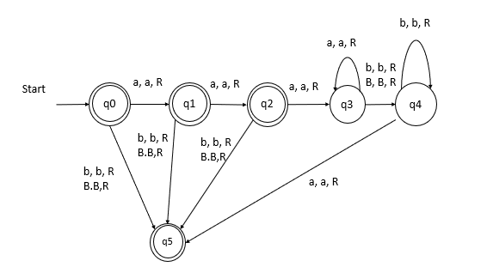

Initial state q0

Final state q5

**9.1 #3**

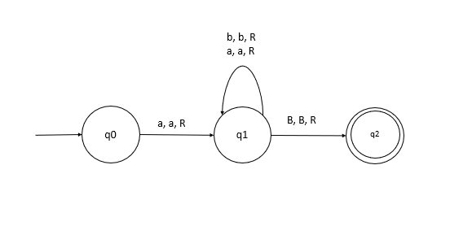

Initial state q0

Final state q2

Accepts test strings of the form L = {a, aa, aab aabb, aaabbb ….}

(q0,a) = (q1, a, R)

(q1,a) = (q1, a, R)

(q1, B) = (q2, B , R)

**9.1 #4**

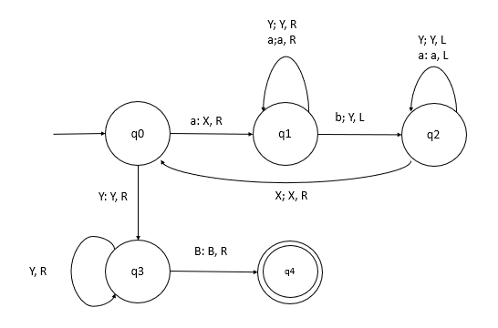

Initial state q0

Final state q4

States q0, q1, q2, q3, q4

Replaces the first a by X and first b by Y and follow on …

Accepts aaabbb 🡪 XaaYbb 🡪 XXaYYb 🡪 XXXYYY

**9.1 #5**

The example 9.7 does not become inifite.

**9.1 #6**

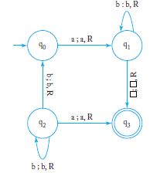

The machine accepts strings of the form L =L{ab* + bb*a}

Test string: aa

Q0 q qB

a Q1 a B

a a Q1 B

final state 🡪 a a B Q3

Test String: bba

Q0 b b a B

b Q1 b a B

b b Q2 a B

final state 🡪 b b a q3 B

**9.1 #7**

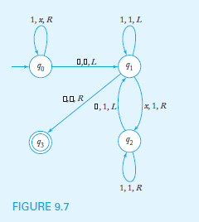

δ(q0, 1) = (q0, x, R)

δ(q0,#) = (q1, #, L)

δ(q1,1) = (q1, 1, L)

δ(q1,x) = (q2, 1, R)

δ(q1,#) = (q3, #, R)

δ(q2,1) = (q2, 1, R)

δ(q2,#) = (q1, 1, L)

**Chapter 12**

**12.1 #1**

δ(qy,a) = (qa, a, R)

δ(qa,a) = (qb, a, R)

δ(qb,a) = (qa, a, L)

**12.1 #4**

Consider the input (M,w) simulates M m1 m2 …mn

Now modify the input to (M, wc) such that when it halts it checks the input and goes into infinite loop whenever the input is not wc.

We can say that (Mc, wc) halts only If (M, w) halts. If (Mc, wc) halts for A we can conclude that it halts for (M, w) too and vice versa

**12.1 #6**

The turing machine is considered to be an inifite array or Tape of cells/state arranged from left to right.

The turing machine accepts the inputs which satifies it condition and moves from one state to another i.e., transitions its state from one to another depending on the condition specified. So it is possible for the turing machine to revisit the state during the course of computation from the starting cell as long as it accepts the algorithm and or the test string which is the specified condition.

**12.2 #1**

W= w1 w2 w3 …wn

Initial satte is q0

δ(q0,c) = (p1, #, R)

δ(qi,c) = (pi+1, wi, R)

δ(qn+1,c) = (pn+1, #, L)

δ(qn+2,#) = (p0, #, R)

construct a new Mc which halts whenever M halts for any given input.

δ(qi,a) = (q, a, R)

δ(q,x) = (q, c, R)

δ(q,#) = (qf, #, L)

qf is the final state

**12.2 #2**

Construct a turing machine T’, when input M will decide if M, given it’s own input will accept or not.

New turing machine is M (input ) accepts if M does not accept own encoding as tape and rejects if M accept own encoding as tape.

If Y is accepted which is a contradiction meaning it cannot accept Y as well as it should reject the input at the same time

Therefore Y does not exists hence we can say that given statement is undecidable.

**12.2 #3**

a) using theorem 12.4 we can construct/modify a machine such that whenever it halts, it accepts a string of length five.

b) modify the original machine so that whenever it halts, it accepts any input string of E*

else it accepts only strings of the form 0n1n

**12.3 #1**

A = w1, w2 , w3 …. Wn

B = v1, v2, v3, …. Vn

There exists a solution for (A,B) such that

Wiwj …. Wk = vi vj …vk

When A = {10, 00, 11, 01}

B = {0, 00, 1, 101}

W1 = 10, w2 = 00, w3 = 11, w4 =01

V1 = 0, v2 = 001, v3 = 1, v4 = 101

Note that: W2,w3,w4,w1 = v2,v4,v3,v1

**12.3 #4**

For some i, which has a trivial solution when |wi| = |wj|, or there must exist aj and ak such that |wj| > |vj| and |wk| < |vk|. therefore solution

Wjrwks where r = |vk| - |wk| and s = |wj | - |vj|

**12.3 #5**

This resulting corresponding problem is no longer decidable.

Any alphabet can be encoded with the two symbol alphabet.

By contradiction, we construct a decier such that PCP folloews the decider S for input (P)

Construct a Pc of BPCP such tat p has a match only if Pc has a match for some input.

There cannot exist a function such that R for BPCP we can run R on Pc and only if Pc also has a match which is contradicted.

R does not exists which decides the outcome of BPCP.therefore BPCP is undecidable.